**AWS & MYSQL**

Connect to running instance:

ssh -i aws-key.pem [ec2-user@ec2-xx-xxx-xxx.eu-west-1.compute.amazonaws.com](mailto:ec2-user@ec2-xx-xxx-xxx.eu-west-1.compute.amazonaws.com)

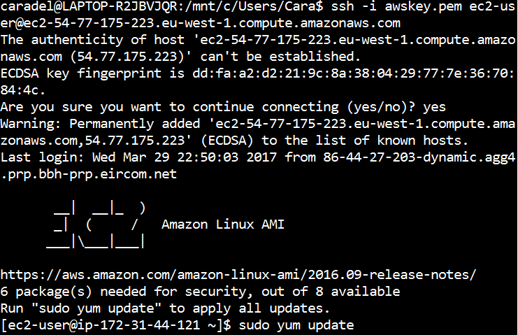

* sudo yum update
* accept download package Y
* sudo yum install mysql mysql-server (sudo yum **remove** mysql mysq-server to remove)
* mysql mysql-server –version (to check remove was successful, if not repeat cmd)
* sudo chkconfig mysqld on
* sudo service mysql start
* /usr/bin/mysql_secure_installation
* Change root password Y/N
* Remove anonymous users: Y
* Disallow root login remotely: Y
* Remove test database and access to it: Y
* Reload privilege tables now: Y

Install config complete

* sudo mysql -p / sudo mysql -uroot -p (type password) #login
* quit to quit sql

how to add users:

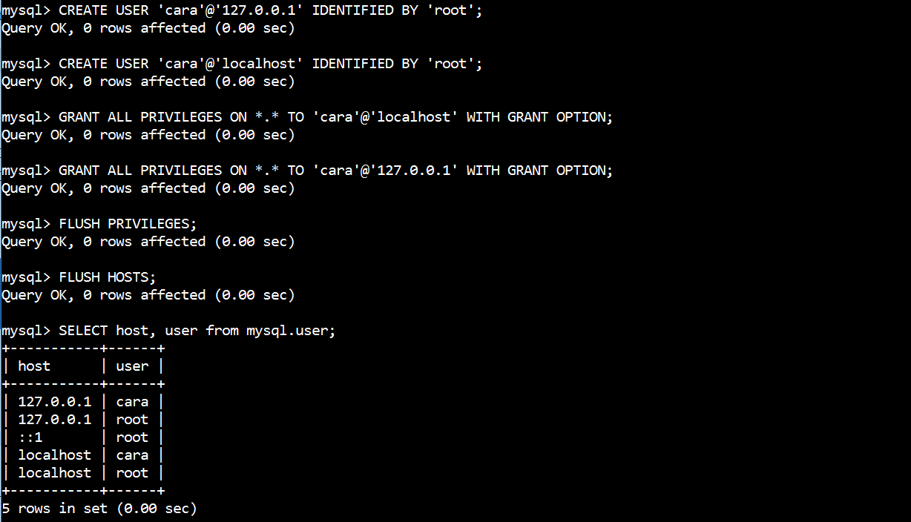

-create user ‘darragh’@’ IP.IP.IP.IP’ identified by ‘password’;

-create database db_darragh;

-grant ALL ON db_darragh.* TO ‘darragh’@’IP.IP.IP.IP’;

-flush privileges;

-flush hosts;

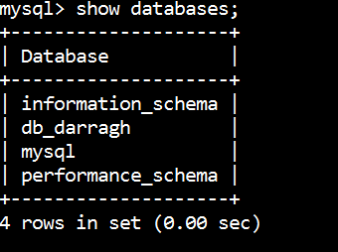

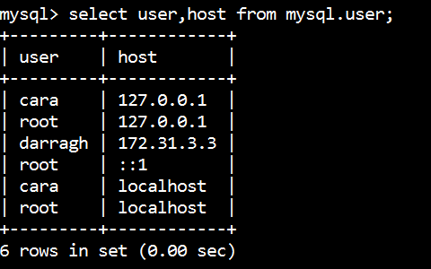

quit mysql

-sudo vim /etc/my.cnf

Insert bind-address=0.0.0.0

--mysql commands for table,db access--

-create user ‘name’@’ip’ identified by ‘password’; (ip, localhost, 127.0.0.1)

-grant all privileges to on *.* to ‘name’@’ip’; (can include with grant option to allow user to give usrs permissions

-flush privileges;

-flush hosts; (to apply changes)

Resources:

https://www.youtube.com/watch?v=zrRQcZeXUhQ

https://www.youtube.com/watch?v=3LGD4Pk9Uok